Process Definition Document (PDD)

*Process Name: Health Care National Insurance Planning*

Table of Contents

**Introduction**1

Purpose of the Document 1

Objectives 1

Process Key Contact 1

Minimum Prerequisites for Automation 2

**As-Is Process Description**2

Process Overview 2

Applications used in the Process 3

As-Is Process Map 4

**To-Be Process Description**6

Detailed Process Map 6

Robot Type 7

Business Exceptions Handling 8

Known Exceptions 8

Unknown Exceptions 8

System Exceptions Handling 8

**Other Observations**9

**Additional sources of process documentation**9



# Introduction

## Purpose of the Document

The Process Definition Document outlines the business process chosen for automation using UiPath Robotic Process Automation (RPA) technology.

The document describes the sequence of steps performed as part of the business process, the conditions and rules of the process prior to automation and how they are envisioned to work after automating it, partly or entirely. This specifications document serves as a base for developers, providing them with the details required for applying robotic process automation to the selected business process.

## Objectives

The business objectives and benefits expected by the Business Process Owner after automation of the selected business process are:

* Reduce redundant activities.
* Deliver faster processing.
* Improve overall performance and reliability.

## Process Key Contact

The specifications document includes concise and complete requirements of the business process, and it is built based on the inputs provided by the process Subject Matter Expert (SME)/ Process Owner.

The Process Owner is expected to review it and provide signoff for accuracy and completion of the steps, context, impact and a set of process exceptions. The details are to be included in the table below.

|  |  |  |  |
| --- | --- | --- | --- |
| Role | Name | Contact Details  (email & phone number) | Notes |
| Process Owner | Juan Cruz | [example@gmail.com](mailto:example@gmail.com)  +57 6001234567 |  |
| Business Analyst | Juan Cruz | [example@gmail.com](mailto:example@gmail.com)  +57 6001234567 |  |

## Minimum Prerequisites for Automation

|  |  |
| --- | --- |
| Met (Y/N) | Prerequisites |
| Y | A filled in and completed Process Definition Document |
| Y | Closure of any open process questions |
| Y | Environment set up |
| Y | Test Data to support development and testing |
| Y | User access and creation of user accounts (licenses, permissions, restriction to create accounts for robots) |

# As-Is Process Description

## Process Overview

General information about the process selected for RPA prior to automation.

|  |  |  |
| --- | --- | --- |
| # | Item | Description |
| 1 | Process Full Name | Health Care National Insurance Planning |
| 2 | Process Area | Personal |
| 3 | Department | Health care |
| 4 | Process Short Description  (Operation, activity, outcome) | Obtain a file with user details, filter the list and fill the form for each set of data into National Insurance Planning form |
| 5 | Role(s) required for performing the process | System 1 user (ACME) |
| 6 | Process schedule and frequency | Daily (recommended End of Day (EOD)) |
| 7 | # of items processed /reference period | 11-23 |
| 8 | Process execution time | VALIDATE THIS |
| 9 | Peak period(s) | N/A |
| 10 | Transaction Volume During Peak period | N/A |
| 11 | Total # of FTEs supporting this activity | N/A |
| 12 | Expected increase of volume in the next reference period | N/A |
| 13 | Level of exception rate | No expected exceptions |
| 14 | Input data | Excel file as an attachment over mail |
| 15 | Output data | Form filled |

*Add more rows to the table to include relevant data for the automation process. No fields should be left empty. Use “n/a” for the items that don't apply to the selected business process.

## Applications used in the Process.

The table includes a comprehensive list of all the applications that are used as part of the process to be automated to perform the given steps in the flow.

|  |  |  |  |  |  |
| --- | --- | --- | --- | --- | --- |
| # | Application Name & Version | System Language | Thin/Thick Client | Environment/ Access Method | Comments |
| 1 | Microsoft Outlook for Microsoft 365 version 2302 | English | Thin | PC |  |
| 2 | Google Chrome version 111.0.5563.65 | English | Thin | PC |  |

*Add more rows to the table to include the complete list of applications.

## As-Is Process Map

**High Level As-Is Process Map:** This chapter depicts the As-Is business process at a High Level to enable developers to have a high-level understanding of the current process.

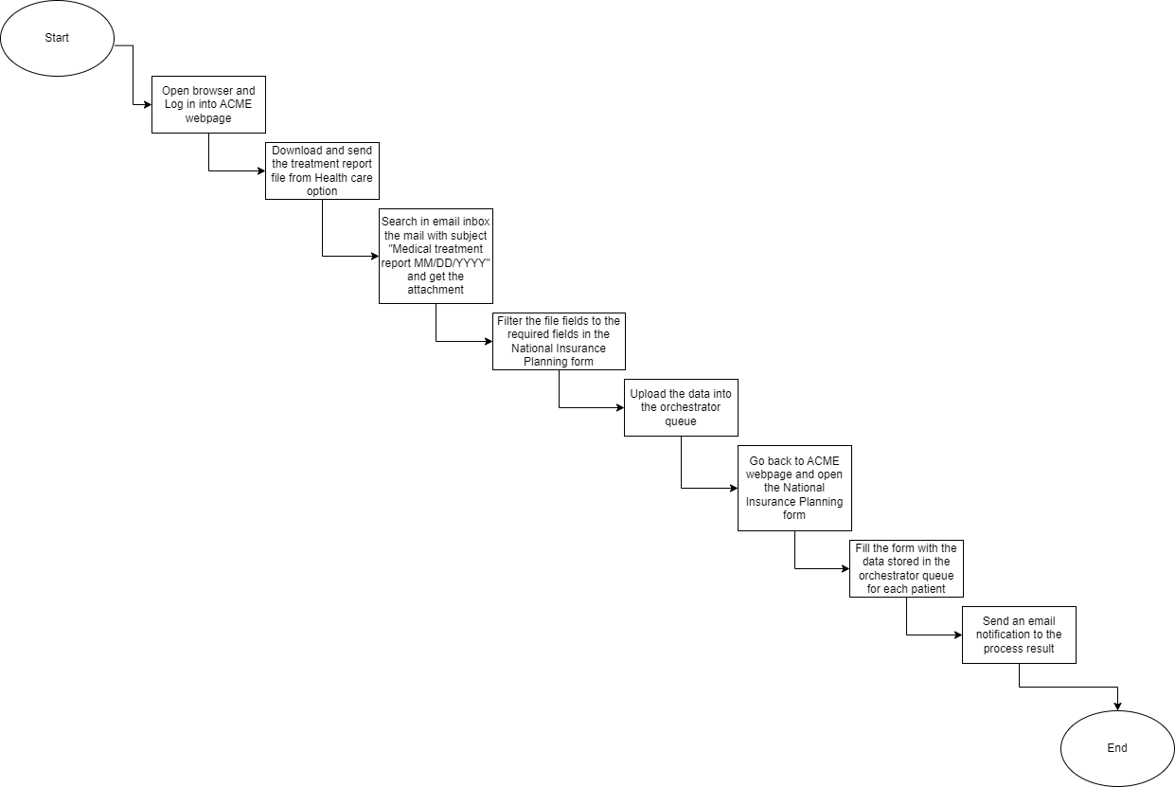

**Detailed Process Map:** This chapter depicts the As-Is business process at a detailed view to enable process owners to document their process.

|  |  |  |  |
| --- | --- | --- | --- |
| # | Step Action/Description | Screenshot | Remarks |
| 1 | Open browser and go to ACME System 1. |  | Chrome browser open to URL  <https://acme-test.uipath.com/login> |
| 2 | Log in to ACME System 1. |  | Username and Password obtained from orchestrator Asset |
| 3 | Open the file with the patient data and download the Treatment report file in the Downloads directory. |  | URL to get the report: <https://acme-test.uipath.com/testdata/medical/Treatment%20Report.csv> |
| 4 | Send an email to myself with the file. |  |  |
| 5 | Read the Unread mails to search the mail with subject:  “Medical_treatment_report_ MM/dd/YYYY”. | Pending |  |
| 6 | Download and filter the file fields to the required fields in the National Insurance Planning form. | Pending | Project directory |
| 7 | Add the values filtered to the orchestrator queue. | Pending |  |
| 8 | Open the National Insurance Planning form in the ACME webpage and fill the form with each set of values obtained from the orchestrator queue. |  | URL to get the form: <https://acme-test.uipath.com/medical/insurance> |
| 9 | Send an email to myself with the notification of the result. | Pending |  |
| 10 | For all the set of data, repeat the steps 8 and 9. | N/A |  |

# To-Be Process Description

## Detailed Process Map

**High Level To-Be Process Map:** This chapter depicts the To-Be automation process at a High Level to enable developers/COE to have a high-level understanding of the to be developed process.

**Detailed Process Map:** This chapter depicts the To-Be automation process at a detailed view to enable developers/COE to see the workflows involved in the RPA solution.

|  |  |  |  |  |  |
| --- | --- | --- | --- | --- | --- |
| **Workflow Name** | **Description** | **Pre-conditions** | **Post-actions** | **Arguments** | **Notes** |
| OpenBrowser | This workflow opens the browser to go to ACME webpage. | N.A | Set the ACME credentials. | in_URL - String |  |
| LoginAcme | This workflow does Login into ACME webpage. | Browser open to set ACME credentials stored in the orchestrator asset. | Go to Health Care 🡪 Download Treatment Report Send email. | N.A | Throw BRE if the page didn’t load, or the login credentials didn’t work. |
| DownloadAndSendReport | This workflow downloads the treatment report from the health care option and sends it through email. | Already logged into ACME webpage Email address to send the email. | Filter the data to the values required in the form. | in_URL_ACME_report - String in_report_email - String | Throw BRE if it is unable to send the email. |
| ProcessFile | This workflow saves the file data to data table and filter the data to get the values to be used in the NIP form. | File downloaded. | Add the values into the orchestrator queue. | N/A |  |
| UploadItemsQueue | This workflow adds the values filtered into the orchestrator queue. | Orchestrator connection | Set the values retrieved from the queue into the form. | N/A |  |
| IterateTreatmentReport | This workflow retrieves the items saved in the orchestrator queue and fills each form. | Already logged into ACME webpage Data extracted and filtered. | Send email notification to the user. | in_URL_ACME_form - String |  |
| SendMailNotification | This workflow sends an email if all the fields in the form has been filled or not. | Form should be filled. | N/A | in_notification_email - String | Throw BRE if it is unable to send the email. |

## Robot Type

|  |  |  |  |  |
| --- | --- | --- | --- | --- |
| # | Attended | Unattended | Trigger | Comments |
| 1 |  | X |  |  |

## Business Exceptions Handling

The Business Process Owner and Business Analysts are expected to document below all the business exceptions identified in the automation process. These can be classified as:

### Known Exceptions

The table below reflects all the business process exceptions encountered during the process evaluation and documentation. These are known exceptions that occurred before. For each of these exceptions, define a corresponding expected action that the robot should complete if it encounters the exception.

|  |  |  |  |  |
| --- | --- | --- | --- | --- |
| BE # | Exception Name | Step | Parameters | Action to be Taken |
| 1 | Incorrect Email or  Password/ACME site  Down | 2 | Check for Log Out button | Log with Error level  and Throw BRE |
| 2 | There are not mails with the subject “Medical treatment report MM/DD/YYYY.” | 5 | N/A | Write info log |
|  |  |  |  |  |

### Unknown Exceptions

For all other unanticipated or unknown business (process) exceptions, the robot should:

* Log with Error level and kill any open applications (Chrome)

## System Exceptions Handling

A comprehensive list of all errors, warnings or notifications should be consolidated here with the description and action to be taken, for each, by the robot.

Errors identified in the automation process can be classified as:

|  |  |  |  |  |
| --- | --- | --- | --- | --- |
| SE # | Exception Name | Step | Parameters | Action to be Taken |
| 1 | Application  Unresponsive | Any | No response/blank  Page | Log with error level  and kill any open  applications |
|  |  |  |  |  |
|  |  |  |  |  |

For all the other unanticipated or unknown system exceptions, send an email to **<placeholder>** and attach a screenshot of the error message.

# Other Observations

Include below any other relevant observations you consider needed to be documented here.

* Future additions to retry when unexpected exception occurs.
* Migrate the process to a REF project.

# Additional sources of process documentation

* N/A